PROJECTS MANAGEMENT

### Course Structure

1. **THE STRATEGIC ENVIRONMENT OF THE PROJECTS**
2. **ORGANIZATIONAL MANAGEMENT THROUGH PROJECTS**
3. **PROJECT QUALITY MANAGEMENT**
4. **FINANCIAL MANAGEMENT OF PROJECTS**
5. **MANAGEMENT OF MATERIAL RESOURCES MANAGEMENT IN PROJECTS**
6. **PROJECT MANAGEMENT USING INFORMATION TECHNOLOGY**
7. **RISK MANAGEMENT IN THE ORGANIZATION THROUGH PROJECTS**
8. **MANAGEMENT OF COMMUNICATION IN PROJECTS**
9. **PROJECT TEAM MANAGEMENT**
10. **SELF-EVALUATION - EVALUATION OF PROJECTS**
11. **IMPLEMENTATION, CONTROL AND MONITORING OF THE PROJECT**
12. **ADVANCED PROJECT MANAGEMENT**
13. **HYBRID PROJECT MANAGEMENT**
14. **PROJECT PROPOSAL ELABORATION / PROJECT IMPLEMENTATION GUIDE APPLICATION MODEL**

## Course description

The course aims to create project managers and develop project management skills for proposing, winning and successfully carrying out projects in a modern society structured by projects within globalized competitive economic and political systems.

Theme "project management" approaches the structural analysis of the field of application in close correlation with strategic environment of projects, human resources management, quality management, material resources management, financial management of projects, risk management, using IT expert systems in correlation with research environment, business environment, and the social and human system.

The course creates a successful professional and personal strategy with an analytical approach to the activity in order to achieve short and long-term performance objectives, with the acquisition by students of the following areas: management of organizations through projects; project management; management of material resources within projects; risk management in projects; quality management in projects; financial management of projects; advanced methods in project management.

## Course objectives

1. The acquisition by the students of the techniques of elaboration of a project proposal;
2. Learning by the students the techniques of implementation, execution and monitoring of projects;
3. The acquisition by the students of the strategies regarding the risk management in projects with the minimization of the negative effect of the risks and the maximization of the opportunities of the risks
4. Creating and developing successful skills for the doctorate through projects
5. Creating and developing successful skills for business management through projects.

## Evaluation course Project Management

1. First course online, on the Microsoft Teams and Moodle platforms - UPB-E-learning.
2. The teaching is done on Microsoft Teams and the support materials are uploaded on Moodle.
3. The second course with physical presence - room CD016-UNSTPB. ([44°26'27.2"N 26°02'57.7"E)](https://maps.app.goo.gl/BpHDXBCUfyc9GKaj9)
4. Evaluation course Projects Management

**Examination with physical presence**

**EXAMINATION DOCUMENT - TEST FILE - WORK WITH EXAMINATION SUBJECTS WILL BE COMPLETED WRITTEN BY HAND - SIGNED EACH PAGE, NUMBERING, NAME - SURNAME, DOCTORAL SCHOOL, DATE, ONLY IN THE SPECIFIC HOURS INTERVAL OF THE LAST**

**HOUR OF SECOND COURSE with physical presence.**

1. **Exam: - Attendance & Test: 50% active course attendance; Test in the last hour course 50%;**
2. **Overdue Test June 2025** with physical presence room CD016-UNSTPB. ([44°26'27.2"N 26°02'57.7"E)](https://maps.app.goo.gl/BpHDXBCUfyc9GKaj9)
3. **Re-Examination Test July 2025** with physical presence room CD016-UNSTPB. ([44°26'27.2"N](https://maps.app.goo.gl/BpHDXBCUfyc9GKaj9) [26°02'57.7"E)](https://maps.app.goo.gl/BpHDXBCUfyc9GKaj9)
4. **Calculation of the final grade: 50% (1) + 50% (2)**

**The final result "ADMITTED" or "REJECTED" will be published on the Moodle website and sent to the Doctoral Schools.**

**The interim result "REJECTED" will be published on the Moodle website, if applicable, on the day**

**morning after the Exam, Overdue, Re-Examination.**

### Words /Actions referential in Project Management

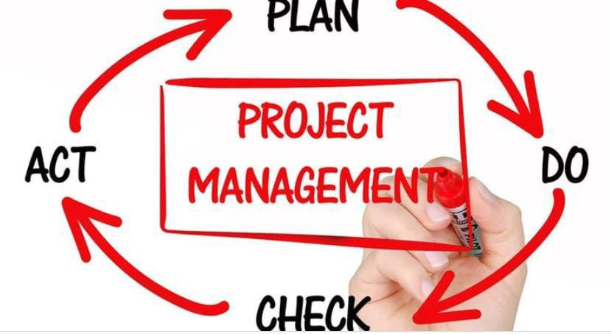

-Innovative

-Intelligent

-Integrated

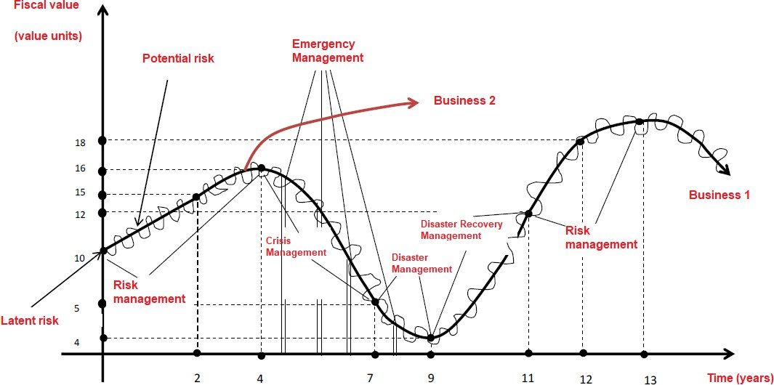

Companies and organisations have specific tasks to achieve from time to time. These may range from new product or software development, installation of new machinery, replacing or upgrading old PP&E, constructing a new building or storage unit, and much more.

These tasks require a combination of resources such as skills, tools, techniques, expertise, labour, finances and time. However, project management is essential where the professional, scientific use of these resources at the utmost potential to complete and achieve such objectives is concerned.

So, what is project management?

### Definition of Project Management

Project management is the systematic professional application of processes to lead teamwork to complete projects using available resources. A project can be defined as any set of tasks or objectives that gives a benefit after completion.

These processes involve skills, finances and other available assets that can be productively used according to project management framework and methodologies to achieve maximal productive output.

Conventionally, project management-related procedures and processes are bound by limitations or specific criteria, including but not limited to:

* Time
* Money
* Labour
* Other available resources and more

Projects vary in nature, which is why different types of projects may require a combination of various resources for completion. Therefore, the resources needed for a project and its respective limitations or bounds are also different depending on the type of project.

### Project Management Core Components

The art of project management for any task or project revolves around several core components. These components can be found in every project undertaken by a project manager and team members for completion.

These core components are:

**Statement of Scope** is the fundamental foundation of a project. It defines a project's necessity, why it is happening, and what value it brings to the customer.

**Critical Success Determinants or Factors** component of project management defines success for a project. It highlights deadlines, customer satisfaction, budget-specific production, employee-related expenses, and quality standards.

**Deliverable Products & Services** define the output of the project. Such result is to be measurable and therefore is included in project estimation. For example, building a new wall with a width of 5 inches & height of 3.67 meters; a 2.5 meters tall fence around the company plot.

**Structure Breakdown for Actual Work**outlines who does what exactly to complete the project. Tables are usually drawn in which tasks are delegated to relevant team members, and a record of utilised resources is kept.

**Scheduling** involves communicating task deadlines. It also consists of the dispensation of duties relevant to completing tasks. Complex systems can be avoided if communication is maintained effectively with transparency.

**Budgeting** involves assigning fixed pools of funds for the completion of tasks. This also sets specified monetary criteria against interrelated tasks. These tasks must be completed within the given boundaries of a project fund.

**Quality Assurance** tasks and output quality checking procedures must be ensured. All functions that yield any output must be checked against set standards. Moreover, such measures for quality checking must also be established.

**HR Utilisation Plan** is a defined plan that answers how, where, what, and when human resources will be employed. Project managers and teams will usually fall under the management of a resource manager for this purpose.

**Stakeholder Listing** all associated stakeholders must be considered before a project's commencement. For this reason, all stakeholders must be listed against their power, interests and concerns.

**Communication Mediums** are the most crucial factor for the success of project management phases. Information obtained from externalities of the project must be thoroughly and efficiently communicated to internal teams.

**A Risk Register** is made to draw up all project-related risks. The primary purpose of a risk register is to identify risks that can arise throughout the life cycle of a project in progress.

**Procuring Procedures** are a thoroughly made procurement plan to obtain project materials, equipment, machinery and resources. This also involves procurement management, including a quality check for obtained materials, usage of materials, and purchasing processes.

### 5 Phases of Project Management

There are five phases of project management which every project undergoes. These are essential and are found throughout all project management plans:

**Initiation**

The first phase of the project management process is to ensure that the project's scope meets and adds value to the concerns of the business. This phase also considers all internal and external stakeholders' concerns.

Project initiation discussions are discussed with project managers, business managers and stakeholders. The criteria against success factors are also determined in this phase against the project's life cycle timeline. A stakeholder register and statement of scope are drafted in this phase.

**Planning**

Planning is the second phase of project management. It involves drafting and outlining the project plan and the procedures and processes teams must perform. Specific requirements to meet deadlines and accomplish tasks with the present resources are detailed.

Experts who manage project teams establish communication to convey the requirements of all associated tasks to perform to meet project goals and objectives. Structure Breakdown for Work, Communication Mediums, Scheduling, Budgeting etc., are formulated at this stage.

**Execution**

The Execution is the third phase which involves all teams following the drafted plans and procedures to complete project tasks. At this stage, a project manager will follow all project plans diligently.

Quality assurance is ensured during this phase of the project cycle so that no task is completed at a compromised quality.

**Monitoring & Control**

Monitoring and controlling are the fourth phase of managing a project. At this stage, a project manager ensures that his teams follow the management plan. This involves tracking progress, team working time, schedule obedience, project requirements, task requirements, and consistently meeting objectives.

If, due to unforeseen circumstances, an extension is required from the stakeholder, tracking the factors mentioned above can provide substantial proof of such a request. External stakeholder communication improves significantly if a project manager has numerical data from monitoring performance indicators.

**Completion or Closure**

Project completion is the last phase of a project or ongoing process cycle. All tasks have been accomplished at this stage, and all relevant processes have been followed. These results are the completion and closure of the project.

At this stage, all relevant documentation is handed over to the appropriate stakeholder board, and closure of the project is formally given.

### Types of Project Management

Depending on the type of project, a project management methodology may vary. Seven project management methodologies are suited for specific projects and work best for them. These are:

**Waterfall Project Management**

Waterfall Project Management is perhaps the simplest type of project management method. Waterfall project management involves the accomplishment of a project in a sequence-based manner with long and detailed timelines.

Waterfall management divides a complete project into several sequential phases, each beginning after the prior one has been achieved, flowing in a sequence like a 'waterfall'.

Unlike Agile, waterfall management discourages flexible changes because the project team follows a linear or straightforward work pattern that conventionally does not change.

**Agile Project Management**

The Agile Project Management methodology combines flexibility with workflow and high-quality output. In Agile project management, project tasks and procedures are divided into small timelines segments called 'sprints'.

Tasks completed in sprints are reviewed consistently by project managers against stakeholder concerns and interests. Moreover, tasks are achieved in small increments of sprints and combined into a more significant project outcome. It is more like the puzzle building blocks that, when combined, yield the complete picture.

Agile project management methodology is more flexible, and changes can be made easily. Although this methodology might be flexible, it still ensures that project output is of the highest quality.

**Scrum Project Management**

Scrum Project Management is an Agile methodology which involves a Scrum Master as a team leader. The Scrum Master ensures that all team members work optimally while keeping the flow of information from external and internal stakeholders, project managers and business managers transparent and timely.

A Scrum Master is an expert that ensures scrum values are being followed within the operational teams. Moreover, daily scrum meetings are called, and tasks are achieved and accomplished within efficient short cycles called 'sprints'. Workflow is highly collaborative.

**Kanban Project Management**

Kanban Project Management is an Agile methodology primarily focusing on visualising workflow and collaborative workflow with continuous feedback loops.

Kanban project management consists of the following principles:

* Visualise Project Workflow
* Decrease Work in Progress
* Managing Workflow Efficiency
* Communicating Workflow Policies & Procedures Explicitly
* Continuous Feedback Loops
* Consistently Improve Team

Kanban prioritises continuous cycles of a project as well as team improvement. Kanban is also found throughout the world's organisations for project management.

**Lean Project Management**

The Lean Project Management method maximises value imparted to the customer. This specific goal is achieved by reducing all waste throughout the production cycle of the project, thus ensuring that the customer receives the highest value.

Lean project management follows the following principles for accomplishing a project:

* Identification of value
* Mapping available value stream (s)
* Creating flow (s)
* Establishing a pull/stream
* Continuous product improvement

**Six Sigma Project Management**

Six Sigma Project Management is a project managing method in which the main focus is on reducing production errors, minimising waste and maximising the end value that the customer receives.

Corporate entities utilising Six Sigma use increased efficiency, which helps reduce production errors and retain maximal customer satisfaction. Consequently, Six Sigma usage allows the following:

* High collaborative measures
* Better & informed decision-making
* Greater end-product quality
* The higher customer satisfaction rate
* Lower production errors

**PRINCE2 Project Management**

The PRINCE2 Project Management approach focuses on completing specified projects, concentrating on controlling tasks and organisational success. The PRINCE2 method of managing projects is also called Projects In Controlled Environments.

This methodology is based on seven critical rules followed throughout a project. These are:

* Clear project justification from a business perspective
* Essential continuous & consistent learning
* Explicit duties and responsibilities
* Planning work is broken down into stages
* Baseline requisites with project boards
* Quality assurance checking against QA registers
* Adjustable tendencies towards meeting the specifics of a project

### 10 Knowledge Areas of Project Management

Apart from the professional frameworks of project management methods, there are ten essential knowledge areas important for project management. These are:

**1. Project Integration Management**

Project integration refers to the cohesive binding of team members in a project. Projects vary in nature and goals. Therefore, identifying teams and recognising skills, expertise, individual values, and binding factors is essential for successful projects and management processes.

Team integration is a big part of project success, and therefore, project integration involves instilling project values and expectations to be integrated with team members and all resources collectively.

**2. Project Scope Management**

Project scope management is the management of the total time required to utilise resources in a specific manner to deliver or produce the final project, product and/or service.

Scope management is contemporary and involves ensuring that teams are aligned on proper workflows to reduce waste and outlay of labour resources, skills, utilities and potential every step of the way. Scope management keeps everyone involved in a project on the same page.

**3. Project Time Management**

Managing time is an essential asset in project management practices. Time is crucially important as it is one of the fundamental factors required for project completion. Completing tasks and achieving goals before deadlines are crucially important. External stakeholders are more inclined towards the deadline-meeting part of the project and finances than a project team's internal working.

**4. Project Cost Management**

Managing costs associated with a project is vital for a project. If costs are handled with proper mechanisms, then costs can decrease over time as production increases.

However, suppose unforeseen risks, events and occurrences related to a project are not considered. In that case, unexpected costs can increase over time and significantly increase the project's total price.

**5. Project Quality Management**

Ensuring quality procedures and production is followed throughout a project's life is essential. Quality standards have to be ensured so that project criteria can be met consistently. If one task is completed at low quality, it can hinder the overall progress of an organisation.

Moreover, low-quality production can induce more problems at the end of the business. Not only does quality impact the project's outcome, but it also may have a butterfly effect on other interconnected departments, processes, tasks and duties.

**6. Project Human Resource Management**

Human resource management occurs because expert people need to work on the project. Human resource management aims to find people with the right skills and expertise to contribute productively to the initiative's progress.

Moreover, managing human resources effectively ensures that costs can be kept low while labour can efficiently be employed. Project managers also hire resource managers responsible for managing human resources.

**7. Project Communication Management**

Project communication is vital in any other corporate or business entity. Communication is crucial in ensuring all project team members understand what is required and how it can be done.

Communication is critical to the project's and the internal team's success, which is always viewed as a cohesive collective result.

**8. Project Risk Management**

Mitigating any risk is essential in ensuring that the project lasts until completion. Hazardous risk consideration is important, and all relevant risks to a project should be accounted for.

Risks related to HR, materials, equipment, tasks, team members, costs, transport etc., are all crucial elements that must be considered for adequate management plans.

**9. Project Procurement Management**

Procurement management involves acquiring project-related materials and resources in the best possible way. The means of how to develop, where to acquire and when to acquire are determinants of a procurement management plan. Therefore, managing procurement procedures is also a central part of a project management plan.

**10. Project Stakeholder Management**

The representation of stakeholders in a project concerns their respective interests. Such concerns must be acknowledged fully for the success of a project. All associated teams, managers, and internal and external stakeholders' interests can be communicated with efficacy.

Project management is a vast discipline interconnected to all these knowledge areas, representing actual practices.

### Benefits of Project Management to Organization

There are numerous benefits of project management practices available to an organisation. Using project management ensures the following outcomes for any organisation:

**1. Improvement in Productivity**

The use of project management processes increases the productivity of available resources. Resource managers, project managers and teams increase an organisation's available output of resources.

**2. Lower Costs**

Using efficient schedules that enhance cost optimising the combination of resources with expert project management knowledge and skills ensures that the price of a project is reduced significantly.

Furthermore, project managers are tasked with completing projects within stipulated budget constraints. That is why an organisation can significantly reduce project costs with budget optimisation by employing project management professionals.

**3. Higher Team Collaborations**

Project management processes are highly collaborative in nature. Due to the complexity of individual team members, a team leader must be appointed to manage complex projects.

Consistent communication is maintained, rigorous checking of workflow and quality assurance standards are tested against work produced, exchange of skills and interrelated expertise of work members - all collectively working to achieve the project's accomplishment.

Therefore, project management promotes greater teamwork, integration and collaboration.

**4. Efficient Control & QA**

Project management procedures have a rigorous phase of testing deliverables' quality for output-producing tasks. This ensures that the customer receives the end product of the highest standards within the set budget and schedule guidelines.

QA is a strict measure in project management. That is why when companies and businesses hire project managers to complete a particular task or objective, they entrust them entirely because the quality of deliverables is assured.

**5. Higher Rate of Customer Satisfaction**

Products and projects are produced at high-quality standards, as mentioned before. That is why customers receiving end products have greater value than production methods not optimised by project management methods.

Therefore, customer satisfaction increases, whereas waste management enhances with low errors and better factor of production optimisation.

**6. Improved Problem Resolving**

Problems arise throughout the life cycle of a project. These problems need timely identification. Once these problems have been identified, problem-solving efforts can be fully employed.

Moreover, a project manager needs to make sure risks can be mitigated if they do arise. That is why project management, in essence, promotes problem-solving attitudes.

### How to Get Started with Project Management?

Are you interested in the vast field of project management as well? Do you have a problem-solving attitude and the hunger to drive successful efforts through teamwork, collaboration and brainstorming?

If you answer yes, you are in the right place to start project management.

Decide the type of certification that interests you.

Finding out what area of project management interests you is the first step, such as project managing, team leading, resource management, costing etc. Once you have identified your interest, you can pick relevant certifications.

Kickstart your project management education

Once you pick a certification, you can register with an accredited institute such as [the Institute of Project Management](https://instituteprojectmanagement.com/). Once enrolled, industry experts will train you professionally in project managing practices.

A project management certification consists of theory, practice, workshops, case-study analysis, quantitative and qualitative reasoning emphasising game theory, Gantt Chart analysis and more in-depth indicators.

Maintain your certification

Once you have achieved your certification, you must fulfil CCR or Continuing Certification Requirement requisites. You must earn a certain amount of PDUs over a period of time.

What is the Institute of Project Management?

The Institute of Project Management is an IPMA-accredited project management institute in Dublin, Ireland. With over 30 years of experience, IPM has committed itself to providing premium quality project management education for professionals, trainees, and students.

IPM has trained over 40,000 students and over 6,000 certified project managers - a proven record since 1989 for excellence and commitment to providing the best education in project management, which is internationally recognised.

Take the first step to transform your career prospects and project your growth to new heights.

Head over to the Institute of Project Management [courses page](https://instituteprojectmanagement.com/courses), pick a certification of interest and start your career transformation by enrolling today.

## Statements:

## SUCCESSFUL PROJECTS LEAD TO SUCCESSFUL COMPANIES STRUCTURED BY PROJECTS WITH AN ORGANIZATIONAL PROJECT MANAGEMENT STRATEGY.

## PROJECT MANAGEMENT REPRESENTS A MANAGERIAL STYLE OF LEADING AN ORGANIZATION, COMPANY, SOCIETY STRUCTURED BY PROJECTS.

## PROJECT MANAGEMENT CREATES A COMPETITIVE ADVANTAGE IN A GLOBALIZED COMPETITIVE MARKET

**THE MAIN STRATEGY IS TO HAVE AN ADAPTABLE FLEXIBLE STRATEGY**

Whenever you make a decision, the best thing is to make the right decision, the next good thing is to make a bad decision, and the most unfavorable choice is to decide to postpone a decision.

SUCCESS IS A TEAM EFFORT!

**IN A PERMANENTLY ADAPTABLE CHANGE SOCIETY, FAILURE IS TRANSITORY**

**A BUSINESS IS VERY HARD TO WIN AND VERY EASY TO LOSE**

**THE ONLY CONSTANT ACTIVITY IS ADAPTIVE DYNAMIC CHANGE**

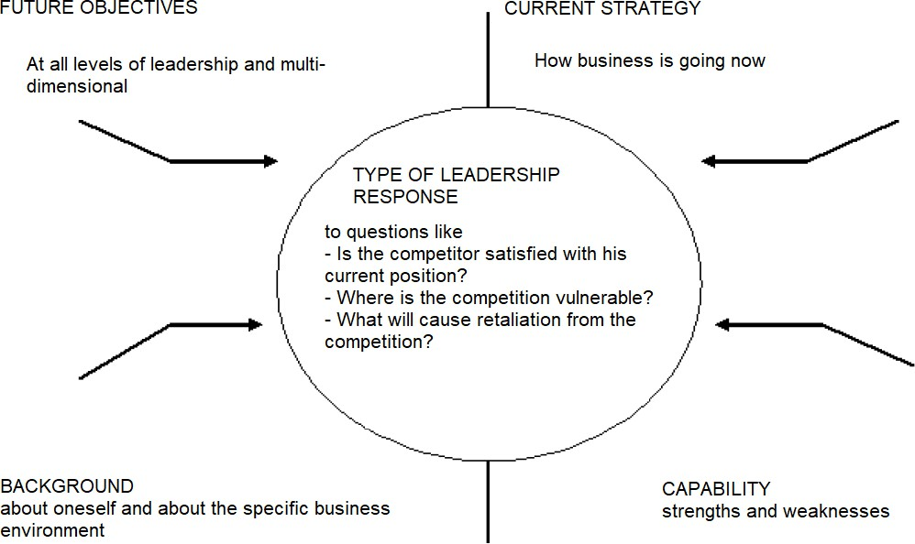

TRUST = THE BEST CAPITAL

**IF A COMPANY EMPLOYEE HAS PROBLEMS, THE COMPANY HAS PROBLEMS**

**THE BIGGEST FAILURE IS TO DO NOTHING.**

#### The project is defined as a non- repetitive process that achieves a new and well-defined amount within specialized organizations. The project is characterized as a unique, specific action, composed of a logical succession of coordinated and controlled component activities, with innovative character of different nature, carried out in a methodically and progressively organized manner, with time, resource and cost constraints, intended to obtain success of new complex results, necessary to meet clearly defined objectives. Project management is defined as a process of planning, organizing, and controlling the phases and resources of a project in order to accomplish a well-defined goal that usually has time, resource, and cost constraints. The role of project management is to direct its development in such a way as to maintain, at all times, the balance between the requirements (specifications), usually contradictory, related to project performance, costs and deadline. Ensuring the success of the project means achieving a high-performance product / service, in conditions of efficiency (low costs), to be offered to the client in the shortest possible time (short response time).



Project management is a tool for planning, coordination, implementation and control of complex activities in the fields of industrial, research, commercial, social, cultural and political development. Any modern activity, modern business is seen as a modern project, with a complex character, which imposes a new vision starting with the analysis of the project needs and ending with the efficient reuse of the project results.

A successful business means an investment in a successful project, with predictable and planned activities.

Successful projects are made with reliable partners who have predictable activities in a predictable market, minimizing the negative effects of risks, developing a strategy for responding to risk factors and controlling risks.

Project management must be approached as a methodology for leading any activity as a project, with the rigor and flexibility necessary to achieve success.

It is considered the step-by-step follow-up of each component

event of the project, respectively of the activity, starting with the use of the basic elements and approaching sophisticated elements as much as necessary

PRINCIPLES OF SUCCESS FOR A PROJECT TEAM:

1. COMPETENCE
2. PERFORMANCE
3. QUALITY
4. ETHICS

Successful business means a number of successful projects in which specialized professional performance blends harmoniously with managerial performance and the ability to work in a team.

### Basic functions of project management

1. project organization
2. project management and execution
3. project monitoring and control
4. completion and reporting of the project

### Project management success

1. Initialization
2. Planning
3. Execution
4. Internal and external monitoring
5. Internal and external control of the project
6. 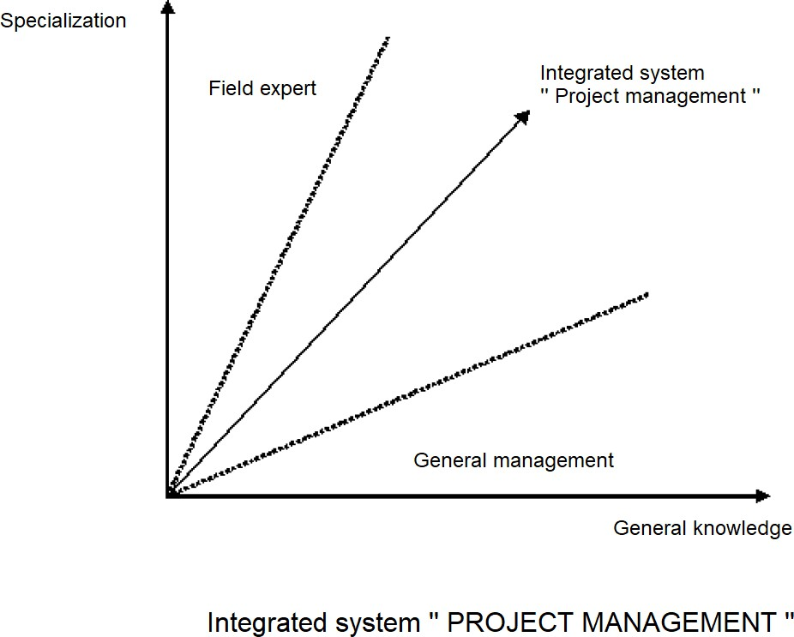Closing / Finalization and reporting of the project

ACTIVITY OF RESEARCH DESIGN IS NOT OPTIONAL BUT ABSOLUTELY MANDATORY FOR A SUCCESSFUL BUSINESS STRATEGY



THE ONLY CONSTANT ACTIVITY IN BUSINESS MANAGEMENT THROUGH PROJECTS IS ADAPTABLE CHANGE

The manager is defined as the person who, by virtue of the tasks, responsibilities and competencies assigned to the position held, exercises management processes, adopts decisions and initiates actions that influence the decisional and action behavior of other persons called executors or partners, in order to increase the efficiency of the structure of which it is part.

The manager is characterized as the best of equals.

The manager deals with the management issues of the design, organizational and general administrative activities of the structure of which he is part (team, organization, company, project consortium, etc.).

The manager must make the most of the activity of those who hired him and for whom he is paid.

### Research or entrepreneurship, what's the connection?

* You are the link. Doctoral students and future Doctors, because you have all the necessary qualities in research, in entrepreneurship and their combination,
* Develop a vision that represents you and virtually check what is missing on the imagined path to fulfill your vision - then you know exactly what remains to be done,
* Do not choose the easiest road, it is only "paved"/easy at the beginning!
* Research work is teamwork - so social qualities are almost as important as

professional ones,

* He who thinks he is somebody has ceased to be somebody.
* With your completed studies, you have the obligation to get involved in everything that surrounds you, to take on responsibilities and obligations and above all, to complete what you start or promise,
* Seek to be an example in society, exclusively promoting activities based on justice, ethics and professional values.

### The qualities and skills necessary for a management position?

* The knowledge necessary for the entire technological process;
* Ability to work in a team;
* Accounting;
* Empathy;
* Sense of observation;
* Imagination;
* Discipline, punctuality, fulfillment of promises;
* Communication, rhetoric, argumentation techniques, foreign languages;
* Confidence in your abilities;
* Perseverance;
* balanced behavior;
* Justice, fairness and ethics;
* Severity and consistent behavior, legality of actions;
* Ability to convince, argue, motivate;
* Knowledge of legislation;

### Patents, implications in research and entrepreneurship



* Completion of the doctoral thesis, respectively the mandatory publications in specialized journals with high impact,
* The doctorate makes new approaches to innovative ideas, their publication and the doctoral
* thesis prevents the submission of a patent,
* For the protection of the intellectual property, but also in view of an economic advantage, an invention patent must be filed,
* In the case of patenting, nothing is allowed to be published until the submitted patent is published,
* Where would it make sense to file a patent?
* In the case of submitting a patent, who owns the property right?
* What kinds of main types of patents are there?
* When is a patent attorney needed and what are the patenting expenses?
* European Unitary Patent.